**Practical No. 9**

Triggers:

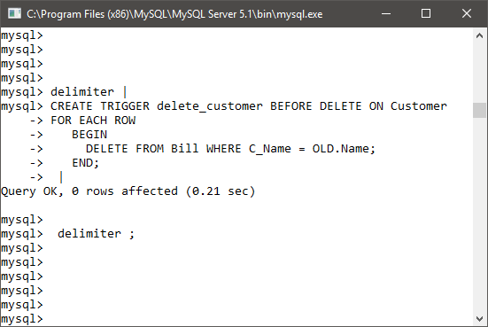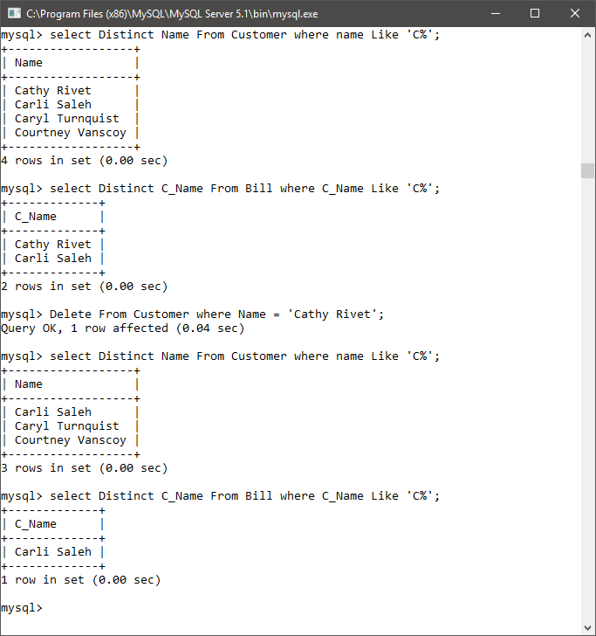

Cursor :

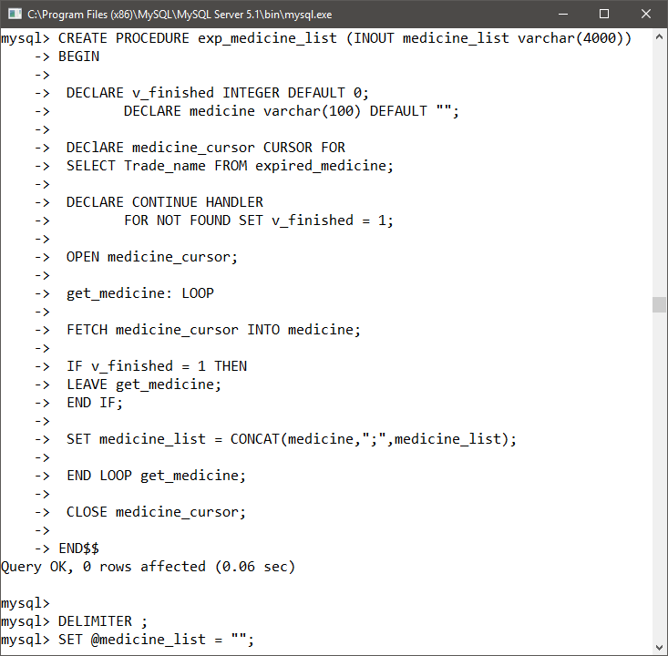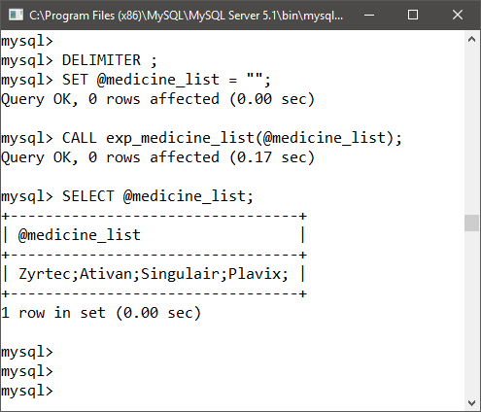

**Practical No. 10**

import java.sql.*;

public class Jdbc_medical_store

{

static

{

try

{

Class.forName("com.mysql.jdbc.Driver");

}

catch (ClassNotFoundException cnf)

{

System.out.println("Driver could not be loaded: " + cnf);

}

}

public static void main(String[] args)

{

String connectionUrl = "jdbc:mysql://localhost:3306/Medical_store";

String dbUser = "root";

String dbPwd = "root";

Connection conn;

ResultSet rs;

String queryString = "SELECT TRADE_NAME FROM EXPIRED_MEDICINE;";

try

{

conn = DriverManager.getConnection(connectionUrl, dbUser, dbPwd);

Statement stmt = conn.createStatement();

rs = stmt.executeQuery(queryString);

System.out.println("Expired Medicines");

System.out.println("============\n");

while(rs.next())

{

System.out.print(rs.getString("Trade_name"));

System.out.println();

}

if (conn != null)

{

conn.close();

conn = null;

}

}

catch (SQLException sqle)

{

System.out.println("SQL Exception thrown: " + sqle);

}

}

}

Output

